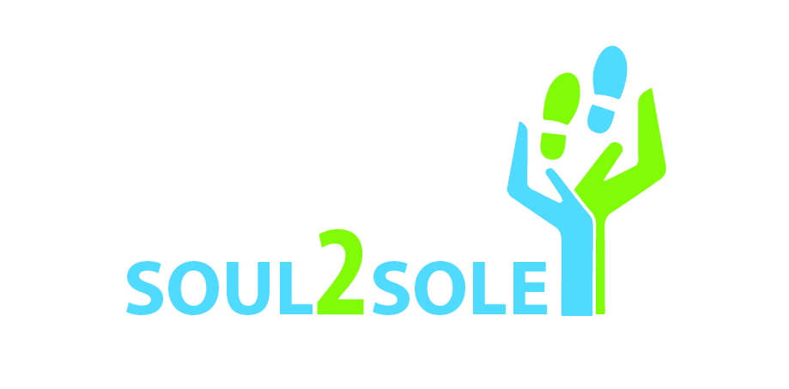

Media Release

13 December 2017

Project Soul2Sole: KZN schools change lives one pair of shoes at a time

Hundreds of learners from 11 schools in the greater Durban area and the KwaZulu-Natal Midlands ended the school year having made a phenomenal difference in the lives of some of the province’s most disadvantaged children. The learners donated more than 1400 pairs of new and pre-loved school shoes as part of NGO, Blue Sky Society Trust’s Soul2Sole initiative in conjunction with The Lion Match Company and Aramex.

Now in its third year running, the Soul2Sole project is aimed at making a meaningful, sustainable impact in our country where more than seven million children have never owned or worn a pair of brand new school shoes.

“We strongly believe that this small and simple gesture can have a ripple effect, bringing hope, pride and dignity to our future leaders,” says Carla Geyser, Founder and Managing Trustee of Blue Sky Society Trust (BSST).

This year, BSST once again teamed up with The Lion Match Company which, in addition to helping with the collection drive for new and pre-owned school shoes, provided each recipient with a Lion Quality shoe polish and a pair of socks.

“As a company, our ethos and spirit centres on changing lives where we can and the Soul2Sole initiative allows us to do this one shoe and one child at a time,” says Milena Domiro, Corporate, Brand and CSI Manager at The Lion Match Company. “It was a chance for us to provide these children, who may have never had a brand new pair of school shoes in their lives, an opportunity to protect their feet on the sometimes arduous journey they make each day to gain a solid education. If we are able to touch one child in this small way, we can help set them on the road to success in their future.”

Learners from Clifton College, Durban Girls' College, Durban Girls' High School, Hilton College, La Lucia Junior Primary School, Chelsea Preparatory School, Maritzburg College, Michaelhouse, Orient Islamic School, Our Lady of Fatima Dominican Convent School and Virginia Preparatory School generously supported the campaign from 4 November 2017 to 6 December 2017. Some of the schools even participated in the “shoe drop” to see first-hand the difference they helped make in local communities. Distribution to rural parts of KZN and neighbouring Eastern Cape will continue in the new year.

“It is only with the help of these pupils, their parents and schools, that we are able to help children who are less fortunate,” says Geyser. “We would like to thank each and every one of you for coming on board - your support has changed lives! We are not just donating shoes to children who really need them. We are delivering hope, dignity and pride – one foot at a time.”

The Soul2Sole initiative has raised more than 3 000 pairs of shoes since BSST started the project with The Lion Match Company three years ago.

For further information and/or interview opportunities, email anisa@kznmc.co.za

Images: Provided
Captions:

1: Durban Girls College learners, Erin Donjeany and Oyama Atlegang, generously donated their school shoes to the Soul2Sole initiative to help disadvantaged school children in KwaZulu-Natal.
2: Milena Domiro, Corporate, Brand and CSI Manager at The Lion Match Company, warehouse assistant, Thobani Mjwara, and Carla Geyser, Founder and Managing Trustee, Blue Sky Society Trust with boxes of new and pre-owned school shoes that are ready for distribution.
3, 4 & 5: Pupils from 10 schools across KwaZulu-Natal contributed to the Soul2Sole project, which distributed new and pre-owned school shoes to children from some of the most disadvantaged areas in and around the province.

ENDS

Issued on behalf of Blue Sky Society Trust by KZN Media and Communications
Email: anisa@kznmc.co.za
Mobile: 072 175 6350
Website: www.kznmc.co.za
Twitter: @anisaussuph

